**HMH**

**Central Database**

**Catalogue**

**Version No 2.1**

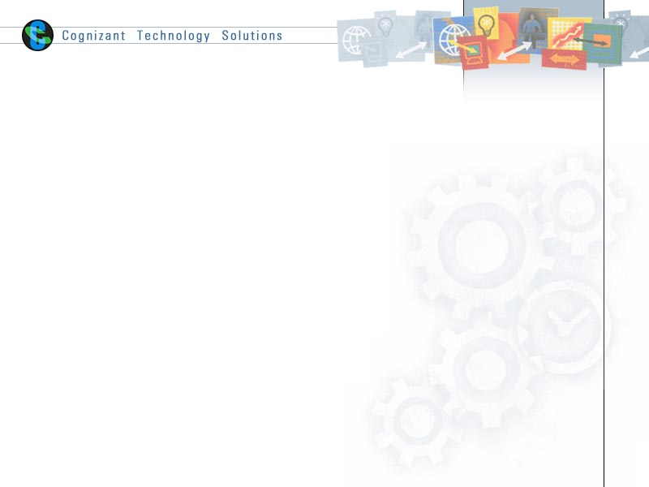

|  |  |  |  |
| --- | --- | --- | --- |
|  | **Prepared By / Last Updated By** | **Reviewed by** | **Approved By** |
| **Name** | Karnati Krishna | Maryada Rajesh |  |
| **Role** |  |  |  |
| **Signature** |  |  |  |
| **Date** | July 11, 2012 |  |  |

Table of Contents

1.0 Introduction 3

1.1 Purpose 3

1.2 Intended Audience 3

1.3 Definitions and Acronyms 3

2.0 What is the Central Database? 4

2.1 How to request a subscriber account 5

2.2 Rules for interacting with database 5

3.0 INTERFACES, TABLES AND VIEWS 5

4.0 ERD Diagram, Tables, Field names 6

4.1 Use of Comments in Tables 7

5.0 Interfaces for Database UPDATE / INSERT 8

5.1 DECODE_V 8

5.2 CUSTOMER Tables 8

5.3 MAT_MATERIAL_V, MAT_PRODUCTHIERARCHY_V 9

5.4 MAT_CLASSIFICATION_V 10

5.5 MAT_PRICING_V 10

5.6 MAT_KITCOMPONENT_V 10

5.7 MAT_PARTNERINFO_V 11

5.8 VENDOR Tables 11

5.9 INV_INVENTORY_V 12

5.10 X_OTS_TRANSACTION_V 12

5.11 X_OTS_INVOICE_V 12

5.12 X_OTS_SHIPMENT_V 13

# Introduction

### Purpose

The purpose of this document is to guide the users/consumers on the design specification followed in Central Database. The document would give an abstract view on the tables being maintained and the update schedule pattern implemented.

### Intended Audience

* + *Team members*

### Definitions and Acronyms

| Acronym | ****Term**** |
| --- | --- |
| CDB | Central Database |
|  |  |
|  |  |
|  |  |
|  |  |

# What is the Central Database?

The Central Database is a repository of SAP published data where consumers (other HMH applications) can connect directly to retrieve the data. The Central Database is updated as soon as the SAP publishes the data, thereby ensuring a more synchronized, accurate and effective storage of SAP data. The basic design structure followed is pictorially represented below:

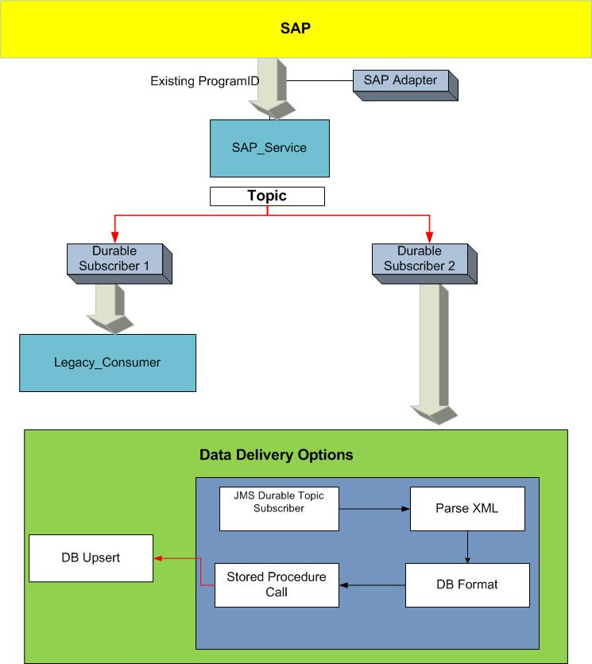

# How to request a subscriber account

For a new account, the group manager should send an email request to “HMH Tibco Support” for approval of access to CDB. The users will have read only permissions on the Views maintained in the Central Database. The end users / consumers of Central Database will retrieve data from configured views. The configured views will provide the updated data from its corresponding tables.

# Rules for interacting with database

1. To ensure proper performance and future compatibility with View changes, all consumers must use specific field names to query a View.   
   **Consumers should NEVER use ‘*’ (i.e. select all).**
2. All the master table Views have “**UPDATE_DATE_DB**” field defined, which provides the latest date and time the specific row is populated. The tables that do not have this field are child tables that are updated at the same time as the parent record in the master table, hence the **UPDATE_DATE_DB** from the parent table record should be reference.
3. If your specific queries take a long time to execute, please submit a ticket to Service Desk and cc: HMH Tibco Support. We will improve the performance of this DB by introducing new indexes.

# INTERFACES, TABLES AND VIEWS

Tables maintained in the Central Database and the corresponding HMH TIBCO Interface which does the upsert process are listed below. The consumers pull the data from the views corresponding to the table mentioned.

Primary key (PK) and Indexed column information is also listed, so that the end users can build the CDB queries based on primary key or index columns for a faster retrieval of the data.

|  |  |  |  |  |  |
| --- | --- | --- | --- | --- | --- |
|  | Interface Name in HMH TIBCO | Tables Updated | **Views Updated** | PK Column | Indexed Column |
| OTS | Apache Camel | X_OTS_TRANSACTION | X_OTS_TRANSACTION_V | TRANSATION_ID | Not Defined |
| Apache Camel | X_OTS_INVOICE | X_OTS_INVOICE_V | INVOICE_ID | Not Defined |
| Apache Camel | X_OTS_SHIPMENT | X_OTS_SHIPMENT_V | SHIPMENT_ID | Not Defined |
| SAPDecodeUpdateCDB | DECODE | **DECODE_V** | Not Defined | Not Defined |
| SAPCustomerUpdateCDB | CUS_CUSTOMER | **CUS_CUSTOMER_V** | CUSTOMERID | UPDATE_DATE_DB |
| CUS_DIVISION | **CUS_DIVISION_V** | CUSTOMERID | CUSTOMERID |
| DIVISION |
| CUS_PARTNER | **CUS_PARTNER_V** | CUSTOMERID | CUSTOMERID |
| DIVISION |
| PARTNERFUNCTION |
| PARTNERCOUNTER |
| SCM | SAPMaterialMasterPartnersUpdateCDB | MAT_PARTNERINFO | **MAT_PARTNERINFO_V** | MATERIALNUMBER | UPDATE_DATE_DB |
| AUTHORID |
| ROLE |
| SAPMaterialMasterPricingUpdateCDB | MAT_PRICING | **MAT_PRICING_V** | Not Defined | UPDATE_DATE_DB |
| SAPMatMasBOMUpdateCDB | MAT_KITCOMPONENT | **MAT_KITCOMPONENT_V** | Not Defined | UPDATE_DATE_DB |
| SAPMaterialMasterUpdateCDB | MAT_MATERIAL | **MAT_MATERIAL_V** | MATERIALNUMBER | ISBN_13 |
| UPDATE_DATE_DB |
| MAT_PRODUCTHIERARCHY | **MAT_PRODUCTHIERARCHY_V** | Not Defined | MATERIALNUMBER |
| SAPMaterialMasterClassificationUpdateCDB | MAT_CLASSIFICATION | **MAT_CLASSIFICATION_V** | Not Defined | UPDATE_DATE_DB |
| SAPVendorUpdateCDB | VEN_VENDOR | **VEN_VENDOR_V** | VENDORNUMBER | UPDATE_DATE_DB |
|  | VEN_VENDOR_EMAIL | **VEN_VENDOR_EMAIL_V** | Not Defined | Not Defined |
|  | VEN_VENDOR_REMIT | **VEN_VENDOR_REMIT_V** | Not Defined | VENDORNUMBER |
| SAPInventoryUpdateCDB | INV_INVENTORY | **INV_INVENTORY_V** | MATERIALNUMBER | UPDATE_DATE_DB |
| PLANT |

# ERD Diagram, Tables, Field names

The fields maintained in each table are tabulated in the excel sheet embedded below. The ERD diagram is also attached below.







The latest versions of these documents are located here: <https://eroom.dp.hmco.com/eRoom/Corporate/IntegrationSupportTeam/0_ea773>

# Use of Comments in Tables

Comments are given against each column of the table view. The comments are similar to a data dictionary, giving complete description of the field.

Example:

Query to get comments on all columns 🡪

Select * from all_col_comments where TABLE_NAME = 'MAT_MATERIAL_V’ and OWNER = 'IC_DATASTORE'

Query to get comments on the specific column 🡪

Select * from all_col_comments where TABLE_NAME = 'MAT_MATERIAL_V' and COLUMN_NAME = 'UPCCATEGORY' and OWNER = 'IC_DATASTORE'

# Interfaces for Database UPDATE / INSERT

# DECODE_V

The decode records are entirely refreshed daily. On subsequent entry of decode data, the previous data in the decode table would be deleted and the new data would be inserted. There are no primary key constraints in this. The **UPDATE_DATE_DB** field of the table would give us the day when DECODE table was last updated.

**IDOC Type** : ZVDECODE01

**Primary Keys :** NA

**Update frequency from SAP:** Full refresh daily

**OTS Related Tables**

# CUSTOMER Tables

The customer data is found in the tables **CUS_CUSTOMER**_V, **CUS_DIVISION**_V and **CUS_PARTNER**_V.

The **CUS_CUSTOMER _V** is the master table and has only one entry for a unique customer.

**CUS_DIVISION_V** and **CUS_PARTNER _V** are the child tables for **CUS_CUSTOMER**_V

Each Customer can have multiple divisions or partners associated to it.

CUS_DIVISION and CUS_PARTNER may or may not have multiple entries pertaining to the divisions / partners of a particular customer in the master table.

When an entry for a particular customer is not present in the CUS_CUSTOMER table, an insert is performed. Else, an update on the existing customer data is made. However, in CUS_DIVISION and CUS_PARTNER, the previous details pertaining to a division and partner of a particular customer is deleted completely and new entries are made.

The **UPDATE_DATE_DB** field in the **CUS_CUSTOMER_V** suggests the last date a particular customer data is updated in all the three tables. The date field doesn’t exist in the two child tables. Hence to get the updated date for the child records, the corresponding **CUSTOMER_ID** will have to be looked up in **CUS_CUSTOMER** table**.** This makes error / incident handling sequential and comprehensible.

**IDOC Type** : DEBMAS06

**Primary Keys :** CUSTOMERID

**Update frequency from SAP:** Hourly Incremental Updates

**SCM Related Tables**

# MAT_MATERIAL_V, MAT_PRODUCTHIERARCHY_V

**MAT_MATERIAL** is the main, parent Material table with more than 100 fields of material details. A particular material would have only one entry in this table and hence MATERIALNUMBER has been assigned as the primary key. The methodology followed is   
**UPDATE** - if a particular material number already has an entry in the table OR  
 **INSERT** – if the material is totally new to the table. The data pertaining to materials which were updated on a specific day can be retrieved with the help of **UPDATE_DATE_DB** field in the table.

In addition to the MAT_MATERIAL table, this interface updates the material hierarchy info in the table **MAT_PRODUCTHIERARCHY** which is a child table for MAT_MATERIAL. A particular material may or may not have a product hierarchy. If it has one, the corresponding entry can be looked up in product hierarchy table. There are no primary keys assigned to **MAT_PRODUCTHIERARCHY** table.

The **UPDATE_DATE_DB** field in the **MAT_MATERIAL** identifies the last date a particular material data is updated in these two tables.

**Update Frequency from SAP:** Hourly incremental updates

**IDOC Type :** ISM__MATMAS03-ZISM_MATMAS03

**Primary Keys :** MATERIALNUMBER

# MAT_CLASSIFICATION_V

This table contains classification details for materials. This table will have multiple entries for the same material number. SAP will automatically send ALL Classifications that contain a value in SAP. Blank/Null classification fields will not be included. When a new set of classification fields for a particular material are triggered from SAP, the old set is removed from the DB and the new one is inserted. **UPDATE_DATE_DB** will give the date when the classification feeds of a particular material are last updated.

**IDOC Type :** ISM__MATMAS03-ZISM_MATMAS03

**Primary Keys :** MATERIALNUMBER , CLASSIFICATIONTYPE and VALUE

**Update Frequency from SAP:** Hourly incremental updates

# MAT_PRICING_V

This table has the List Price and subscription details for materials .One material can have multiple pricing entries in this table, with different effective dates. When a new set of Pricing records for a particular material are triggered from SAP, the old set is removed from the CDB and the new one is inserted. There are no primary keys assigned to this particular table. **UPDATE_DATE_DB** will give the last date when the pricing details of a particular material are last updated.

**IDOC Type :** ZPRICECOND01

**Primary Keys :** NA

**Update Frequency from SAP:** Hourly incremental updates

# MAT_KITCOMPONENT_V

This table has kit component details of a material. A particular material can contain multiple Kit Components and hence multiple rows may be found for a particular material in the table. To get details on the kit components themselves, the ‘Component’ id should be looked up in the Mat_Material tables. No Primary keys have been assigned in this table.

**IDOC Type :** BOMMAT03**-**ZBOMMAT03

**Primary Keys :** NA

**Update Frequency from SAP:** Every week day (Mon-Fri) at 8:00PM or 9:00PM

# MAT_PARTNERINFO_V

A material can have different partners associated to it and hence for the same material number we would find multiple entries in the Partners table.

Whenever an iDoc containing partner info is triggered from SAP, the existing partner details would be deleted from the DB and new info would be inserted. This table contains **UPDATE_DATE_DB** whichgives us the date when the partner details of a particular material are last updated

**IDOC Type :** ISM__MATMAS03-ZISM_MATMAS03

**Primary Keys :** MATERIALNUMBER, AUTHORID and ROLE

**Update Frequency from SAP:** Hourly incremental updates

# VENDOR Tables

The Vendor Update interface updates three tables: **VEN_VENDOR_V, VEN_VENDOR_EMAIL_V and VEN_VENDOR_REMIT_V**. VEN_VENDOR_EMAIL and VEN_VENDOR_REMIT are the child tables of VEN_VENDOR table. EMAIL and REMIT details would be separated out from the same iDoc and data would be updated in the corresponding tables. Again, the methodology of update/ insert followed is similar to that followed in a material table. EMAIL and REMIT tables might have multiple entries for the same vendor. The way to find out the last updated date in these tables is similar to that customer or material tables. The **VENDORNUMBER** field is common to all three tables and thus we can look the corresponding value in **VEN_VENDOR** to obtain **UPDATE_DATE_DB** field

**IDOC Type :** CREMAS01-ZCREMAS01

**Primary Keys :** VENDORNUMBER

**Update Frequency from SAP:** Every day at 9:00PM

# INV_INVENTORY_V

The Available To Promise (ATP) inventory details of materials are maintained in the inventory table. There would be unique combination of material and plant in the inventory table. MATERIALNUMBER field has been set as the primary key for faster retrieval of data. The UPDATE_DATE_DB field helps us keep track of the last date when the inventory data of a material is updated.

**IDOC Type :** ZMINVUPD01

**Primary Keys :** MATERIALNUMBER

**Update frequency from SAP:** Plant 0100 sent week days (Mon-Fri), at 9:00PM all other plants sent once per week on Saturday at 9:00AM

# X_OTS_TRANSACTION_V

The view contains the transaction idoc details pertaining to that of an order. The transaction xml created in TIBCO interface is put on to a queue which the apache camel application listens to. The xml, which contains all the details of an order, is then updated in DB by the application

**IDOC Type :** ORDERS05 – Z_ORDERS_UPD

**Primary Keys :** TRANSACTION_ID

**Update Frequency from SAP:** Hourly incremental updates

# X_OTS_INVOICE_V

The view contains the details of an invoice. The invoice xml created in TIBCO interface is put on to a queue which the apache camel application listens to. The xml, which contains all the details of an invoice, as such is then updated in DB by the application.

**IDOC Type :** INVOIC02– Z_INVST_UPD

**Primary Keys :** INVOICE_ID

**Update Frequency from SAP:** Hourly incremental updates

# X_OTS_SHIPMENT_V

The view contains the shipment details of an order. The delivery xml created in TIBCO interface is put on to a queue which the apache camel application listens to. The xml, which contains all the details of a delivery, is then updated in DB by the application

**IDOC Type :** DELVRY01– Z_DELST_UPD

**Primary Keys :** SHIPMENT_ID

**Update Frequency from SAP:** Hourly incremental updates